**Industry report of Hotels and Tourism**

*As of Q3 2024/25*

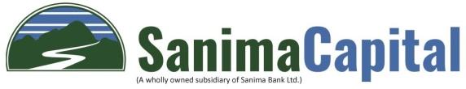

Prepared By:

Research Department

Sanima Capital Limited

*sanimacapital@sanimabank.com*

# Industry report of Hotels Q3 2024/25

## Introduction

The hotel industry in Nepal is a vital component of the country’s tourism sector, contributing significantly to its economy and employment. Nestled in the Himalayas, Nepal attracts millions of tourists annually, drawn by its natural beauty, cultural heritage, adventure opportunities, and spiritual experiences. The hospitality industry plays a crucial role in accommodating and serving this diverse group of travelers, ranging from luxury-seeking adventurers to budget-conscious backpackers and pilgrims.

## Importance of the Hotel Industry in Nepal:

* Economic Contribution: The hotel industry is a key contributor to Nepal's GDP, generating revenue through domestic and international tourism.
* Employment Opportunities: The sector employs a significant portion of the workforce, from management roles to service staff.
* Cultural Promotion: Hotels often serve as gateways for tourists to explore Nepalese culture, food, and traditions, thereby enhancing the country's global image.
* Support to Allied Industries: The growth of the hotel industry supports various allied sectors, such as transportation, agriculture, and handicrafts.

As of March 2025, six hotel and tourism companies are listed on the Nepal Stock Exchange (NEPSE):

Soaltee Hotel Limited (SHL):

**S**oaltee Hotel Limited is one of Nepal's premier five-star hospitality companies with a rich history spanning over 56 years in the tourism and hospitality sector. The company owns and operates "The Soaltee Kathmandu," a luxury hotel property located in Tahachal, Kathmandu.

The Soaltee Kathmandu features 285 saleable rooms ranging from deluxe rooms to club rooms and suites. The hotel offers comprehensive amenities including multiple restaurants (such as Kakori Indian Restaurant, Garden Terrace Restaurant, and Bao Xuan Chinese Restaurant), bars like Rodi Bar, conference spaces including Megha Malhar Hall, and recreational facilities.

Beyond its flagship hotel, Soaltee Hotel Limited has expanded its brand presence through its wholly-owned subsidiary, Soaltee Hospitality Limited. This has allowed them to extend the "Soaltee" brand to other locations outside Kathmandu Valley with properties such as Soaltee Westend Resort in Chitwan, Soaltee Westend in Itahari, Soaltee Westend Resort in Kaskikot (Pokhara), and Soaltee Westend Resort in Nagarkot.

The company also operates The Soaltee Gate Gourmet, an inflight catering division that provides services to international airlines under a technical assistance agreement with Gate Gourmet Singapore Pte. Limited.

Soaltee Hotel Limited is publicly listed on the Nepal Stock Exchange (NEPSE), with major corporate shareholders holding 69% of shares and general shareholders owning the remaining 31%.

Taragaon Regency Hotel Limited (TRH): Manages the Hyatt Regency Kathmandu, the largest five-star hotel in Nepal, located near the Boudhanath Stupa. Hyatt Regency. Opened in 2000 and formally inaugurated by King Birendra, the hotel is built on 37 acres of land showcasing traditional Newar architecture.

The property features 280 guest rooms, including seven luxurious suites, and is operated by Taragaon Regency Hotels. It employs approximately 400 workers, with the majority affiliated with the All Nepal Hotel, Casino and Restaurant Workers Union.

The hotel was established through a public-private partnership, with initial ownership split between the Tourism Ministry's Taragaon Development Committee (40% public ownership) and private partners, primarily the Radheshyam Sharaf and Ramlal Shrestha families (60% private ownership).

As of 2020, the Taragaon Development Committee has been working to reclaim the public land on which the hotel is built back into public ownership, amid allegations that the private partners may have deliberately shown losses to illegally increase their ownership stake in the hotel.

Oriental Hotels Limited (OHL): Oriental Hotels Limited was incorporated as a private limited company in 1994 before converting to a listed public company in 1999. OHL is a single property company that owns and operates a 260-key Radisson Kathmandu located in central Kathmandu, approximately 5 kilometers from Tribhuvan International Airport. The hotel is built on a 1.6-acre (approximately 6,500 square meter) plot in the embassy district.

OHL operates under a franchise agreement with the Radisson Group of Hotels, a global hotel chain, though the hotel maintains domestic management. This partnership, established in 1999, provides OHL access to the Radisson brand name, the global reservation system, and management expertise.

The company is predominantly owned by the Shrestha family, which holds almost the entire promoter stake of approximately 70%. The family has extensive experience in owning and operating high-end hotels and has established strong traction in the local market.

The company has a diversified revenue profile that includes room revenues, food and beverage earnings (supported by banquet operations), and income from operating an executive lounge at the Kathmandu International Airport terminal. OHL is currently expanding its property with the addition of 30 serviced apartments expected to be completed by late FY2024 or early FY2025. Operates the Radisson Hotel in Kathmandu, offering luxury accommodations and services.

Chandragiri Hills Limited (CGH):Chandragiri Hills Limited was established in 2009 and has developed a unique tourism facility that combines a cable car service with a 100-room boutique resort and various adventure/amusement activities. The company is strategically located on a scenic mountain near Nepal's capital city, with the cable car providing access to a location of religious and historical significance.

The company is primarily promoted by individuals associated with the IME Group, with Mr. Hem Raj Dhakal (who also serves as chairman) and Mr. Chandra Prasad Dhakal being the largest shareholders, each holding approximately 19% ownership. Other major stakeholders include Bhat-Bhateni Supermarket Private Limited (one of Nepal's largest retail chains) and several individual investors.

Kalinchowk Darshan Limited (KDL):Kalinchowk Darshan Limited was incorporated on January 20, 2015, and is promoted by both individual and institutional investors from various backgrounds. The company's primary business is a cable car project that connects the bottom station at Kuri Valley to the Kalinchowk Temple located at the top of the mountain. The cable car journey spans approximately 1 kilometer and utilizes 4 gondolas (2 gondolas per system) with a capacity to transport 192 passengers per hour in one direction. The project is strategically located in one of Nepal's major religious destinations, approximately a six-hour drive from Kathmandu. Kalinchowk Temple at the top station attracts numerous pilgrimage visitors throughout the year (except during monsoon season). During the winter season (November-March), the area also becomes popular with domestic and foreign tourists for sightseeing and winter adventure sports, with nearly half of the company's annual revenue generated during this period.

City Hotel Limited (CITY):City Hotel Limited (CHL) is a 5-star hotel property located in Soalteemode, Kathmandu, Nepal. The hotel operates under the brand name "Hyatt Place" and is part of the Golyan Group of companies. City Hotel Limited was incorporated on December 5, 2007, but began commercial operations relatively recently in November 2021.

The property features 153 room keys and includes modern amenities such as food and beverage service, spa, conference hall, casino, and other facilities. The hotel has a management agreement with Hyatt International-South West Asia Limited (owned by Hyatt Hotels Corporation), which provides the hotel with brand recognition, marketing support, and operational expertise.

The hotel is currently planning to upgrade from Hyatt Place to Hyatt Centric, which along with an expansion of its banquet hall capacity and the opening of an on-site casino, is expected to boost revenue.

These companies represent the hotel and tourism sector on NEPSE, offering investors opportunities to participate in Nepal's growing tourism industry.

Additionally, several other hotel and tourism companies are in the pipeline to issue Initial Public Offerings (IPOs) and list on NEPSE, indicating a positive trend towards the expansion and formalization of the sector.

This chart shows three different market metrics tracked over time from Q1 2014/15 to Q3 2024/25 of the hotels industry. The first is the NEPSE (Nepal Stock Exchange) index. The second metric is the Hotels and Tourism Index, the third metric is the PB (Price-to-Book) Ratio, depicted by blue dots, which measures the relationship between market value and book value of companies.

The data suggests a significant transformation in the market dynamics around 2020, with all metrics showing substantially higher levels in the post-2020 period compared to the 2014-2019 period. This could indicate structural changes in market valuations and investor sentiment during and after the pandemic period.

Tourist arrivals demonstrate remarkable recovering from the pandemic under 200,000 visitors in 2020-2021 to reach 114,501 in March 2025, representing a near-complete recovery to pre-pandemic monthly levels of 120,000-134,000 seen in late 2019.

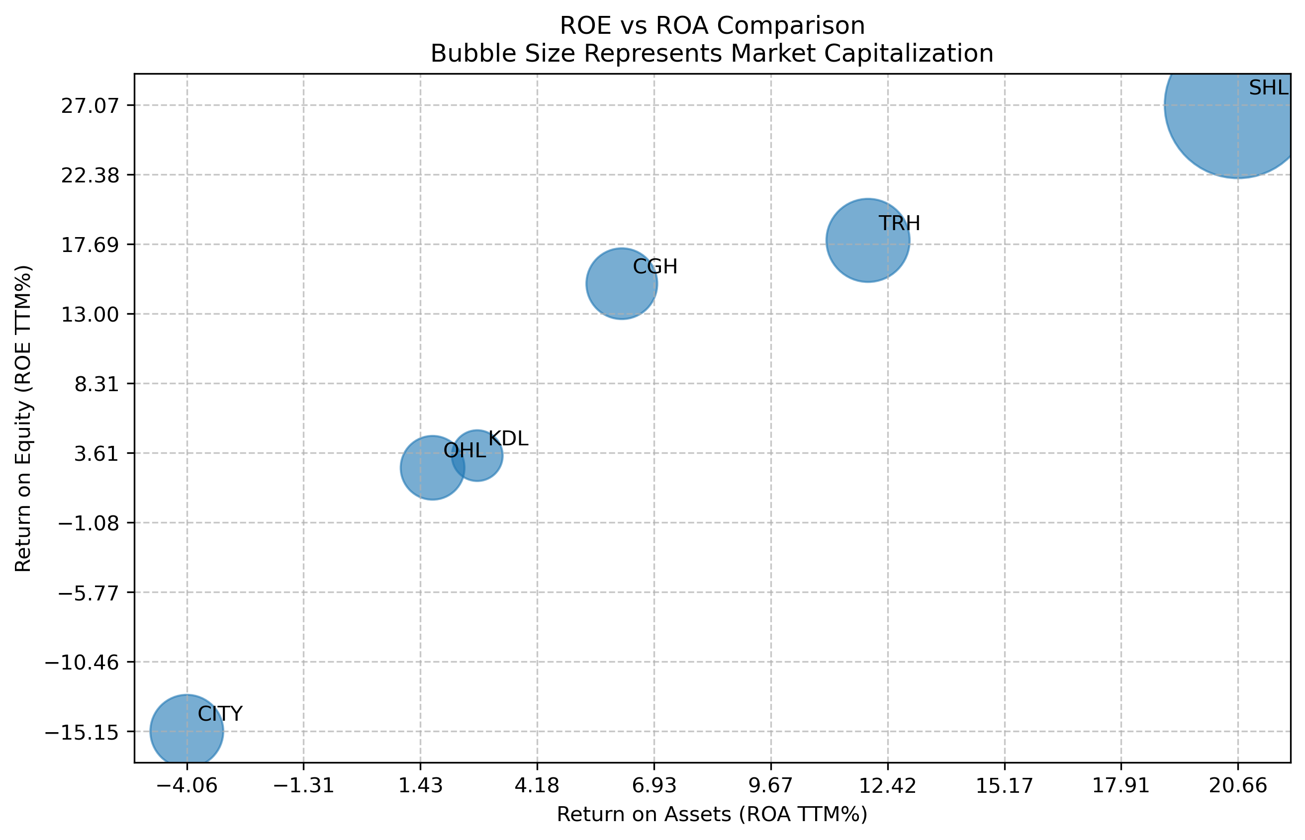

This bubble chart compares ROE (Return on Equity) vs ROA (Return on Assets) for several companies, with bubble sizes representing their market capitalization. The data reveals a clear positive correlation between ROE and ROA across the companies, suggesting that efficient asset utilization generally translates to better returns for shareholders. At the top end of performance, SHL leads with impressive metrics followed by TRH and CGH showing strong performance.

## Key ratio

|  |  |  |  |  |  |  |  |  |
| --- | --- | --- | --- | --- | --- | --- | --- | --- |
| **Particulars** | **CGH** | **CITY** | **KDL** | **OHL** | **SHL** | **TRH** | **Industry Average** | **Industry Median** |
| **Total Income YOY % Growth** | -9.50% | -10.79% | -18.58% | -9.14% | 12.48% | 6.21% | -7.11% | -9.32% |
| **Total Operating Expenditure YOY % Growth** | -1.7% | 0.1% | 13.3% | -4.4% | 11.4% | 7.9% | 3.7% | 4.0% |
| **Investments YOY % Growth** | 3.2% | -86.8% | 7.9% | -3.4% | 2.2% | 0.0% | -15.4% | 1.1% |
| **EPS (Annualized)** | 9.5 | (13.8) | 4.2 | 5.0 | 6.1 | 22.9 | 2.2 | 5.6 |
| **EPS TTM (Rs.)** | 14.6 | (13.4) | 3.5 | 8.5 | 6.4 | 26.6 | 3.9 | 7.5 |
| **Return on Equity (TTM) %** | 15.0% | -15.1% | 3.4% | 2.6% | 27.1% | 17.9% | 6.6% | 9.2% |
| **Return on Assets (TTM) %** | 6.2% | -4.1% | 2.8% | 1.7% | 20.7% | 12.0% | 0.05 | 0.04 |
| **Book Value per Share** | 102.5 | 79.9 | 103.8 | 330.8 | 25.2 | 152.6 | 128.4 | 103.1 |

The table provides a comparative analysis of six listed hotel companies (CGH, CITY, KDL, OHL, SHL, TRH) in terms of key financial metrics such as income growth, expenditure growth, earnings per share (EPS), returns, and book value per share.

## ****Revenue Growth & Recovery Trajectory****

* Only 2 of 6 companies showing positive growth: SHL (12.48%) and TRH (6.21%) leading recovery
* Remaining 4 companies in contraction: CGH (-9.50%), CITY (-10.79%), KDL (-18.58%), OHL (-9.14%)

## ****Profitability & Operational Efficiency****

* Margin leaders: KDL (60.17% gross), SHL (30.42% operating), TRH (28.88% net profit)
* CITY showing severe distress: -51.20% operating margin, -41.87% net margin.

|  |  |  |  |  |  |  |  |  |
| --- | --- | --- | --- | --- | --- | --- | --- | --- |
| **Particulars** | **CGH** | **CITY** | **KDL** | **OHL** | **SHL** | **TRH** | **Industry Average** | **Industry Median** |
| **Market related ratio** | | | | | | | | |
| *LTP* | 876.75 | 850.53 | 1153.26 | 920.97 | 563.14 | 945.74 |  |  |
| *Earnings Yield* | 1.67% | -1.58% | 0.30% | 0.93% | 1.14% | 2.82% | 0.49% | 1.03% |
| *P/E* | 59.97 | - | 332.36 | 107.91 | 87.70 | 35.51 | 117.59 | 73.83 |
| *P/B* | 8.55 | 10.64 | 11.11 | 2.78 | 22.38 | 6.20 | 11.09 | 9.60 |
| *Market Capitalization (in Billions)* | 13.45 | 14.24 | 6.92 | 10.91 | 57.55 | 18.56 | 20.61 | 13.84 |
| *Beta of stock (weekly)* | 1.1 | 1.17 | 1.04 | 0.98 | 0.86 | 0.95 | 1.03 | 1.01 |
| **Solvency ratio** | | | | | | | | |
| *Debt to Equity* | 1.13x | 2.43x | 0.08x | 0.40x | 0.08x | – | 0.82x | 0.24x |
| *Interest Coverage (TTM)* | 2.97x | 0.56x | 4.33x | 3.59x | 290.23x | – | 60.34x | 3.28x |
| **Profit Margin** | | | | | | | | |
| *Gross Profit Margin (TTM)* | 54.18% | 29.65% | 60.17% | 26.89% | 36.15% | 41.72% | 41.41% | 38.93% |
| *Operating Profit Margin (TTM)* | 24.25% | (51.20%) | 28.09% | 10.40% | 30.42% | 36.68% | 8.39% | 26.17% |
| *Net Profit Margin (TTM)* | 23.78% | (41.87%) | 27.33% | 8.87% | 24.24% | 28.88% | 8.47% | 24.01% |
| *Equity Multiplier (TTM)* | 2.26 | 3.48 | 1.11 | 1.42 | 1.14 | 1.07 | 1.88 | 1.28 |
| *Asset turnover* | 0.27 | 0.12 | 0.11 | 0.20 | 0.93 | 0.57 | 0.32x | 0.23x |
| *ROE (Due Point 2 factor)* | 14.27% | -16.80% | 3.34% | 2.58% | 25.52% | 17.45% | 5.78% | 8.80% |

## Market-Related Ratios

The market-related ratios reveal significant valuation disparities across Nepal's hotel industry:

Market Related Ratios

### ****Valuation Leaders & Laggards:****

* **TRH - Premium Value Opportunity:** Trading at 35.5x P/E with highest earnings yield (2.82%), representing 52% discount to industry median (73.8x P/E). Market cap of NPR 18.56 billion appears undervalued given solid operational fundamentals.
* **KDL - Extreme Overvaluation:** 332x P/E ratio completely disconnected from 3.34% ROE performance. Speculative premium unsustainable at current levels.
* **SHL - Quality Premium Justified:** 87.7x P/E supported by superior returns (27.1% ROE). Largest market cap (NPR 57.55 billion) reflects market recognition of operational excellence.
* **CITY - Distressed Valuation:** Negative earnings yield (-1.58%) reflects operational losses. High P/B (10.64x) suggests asset impairment risk.

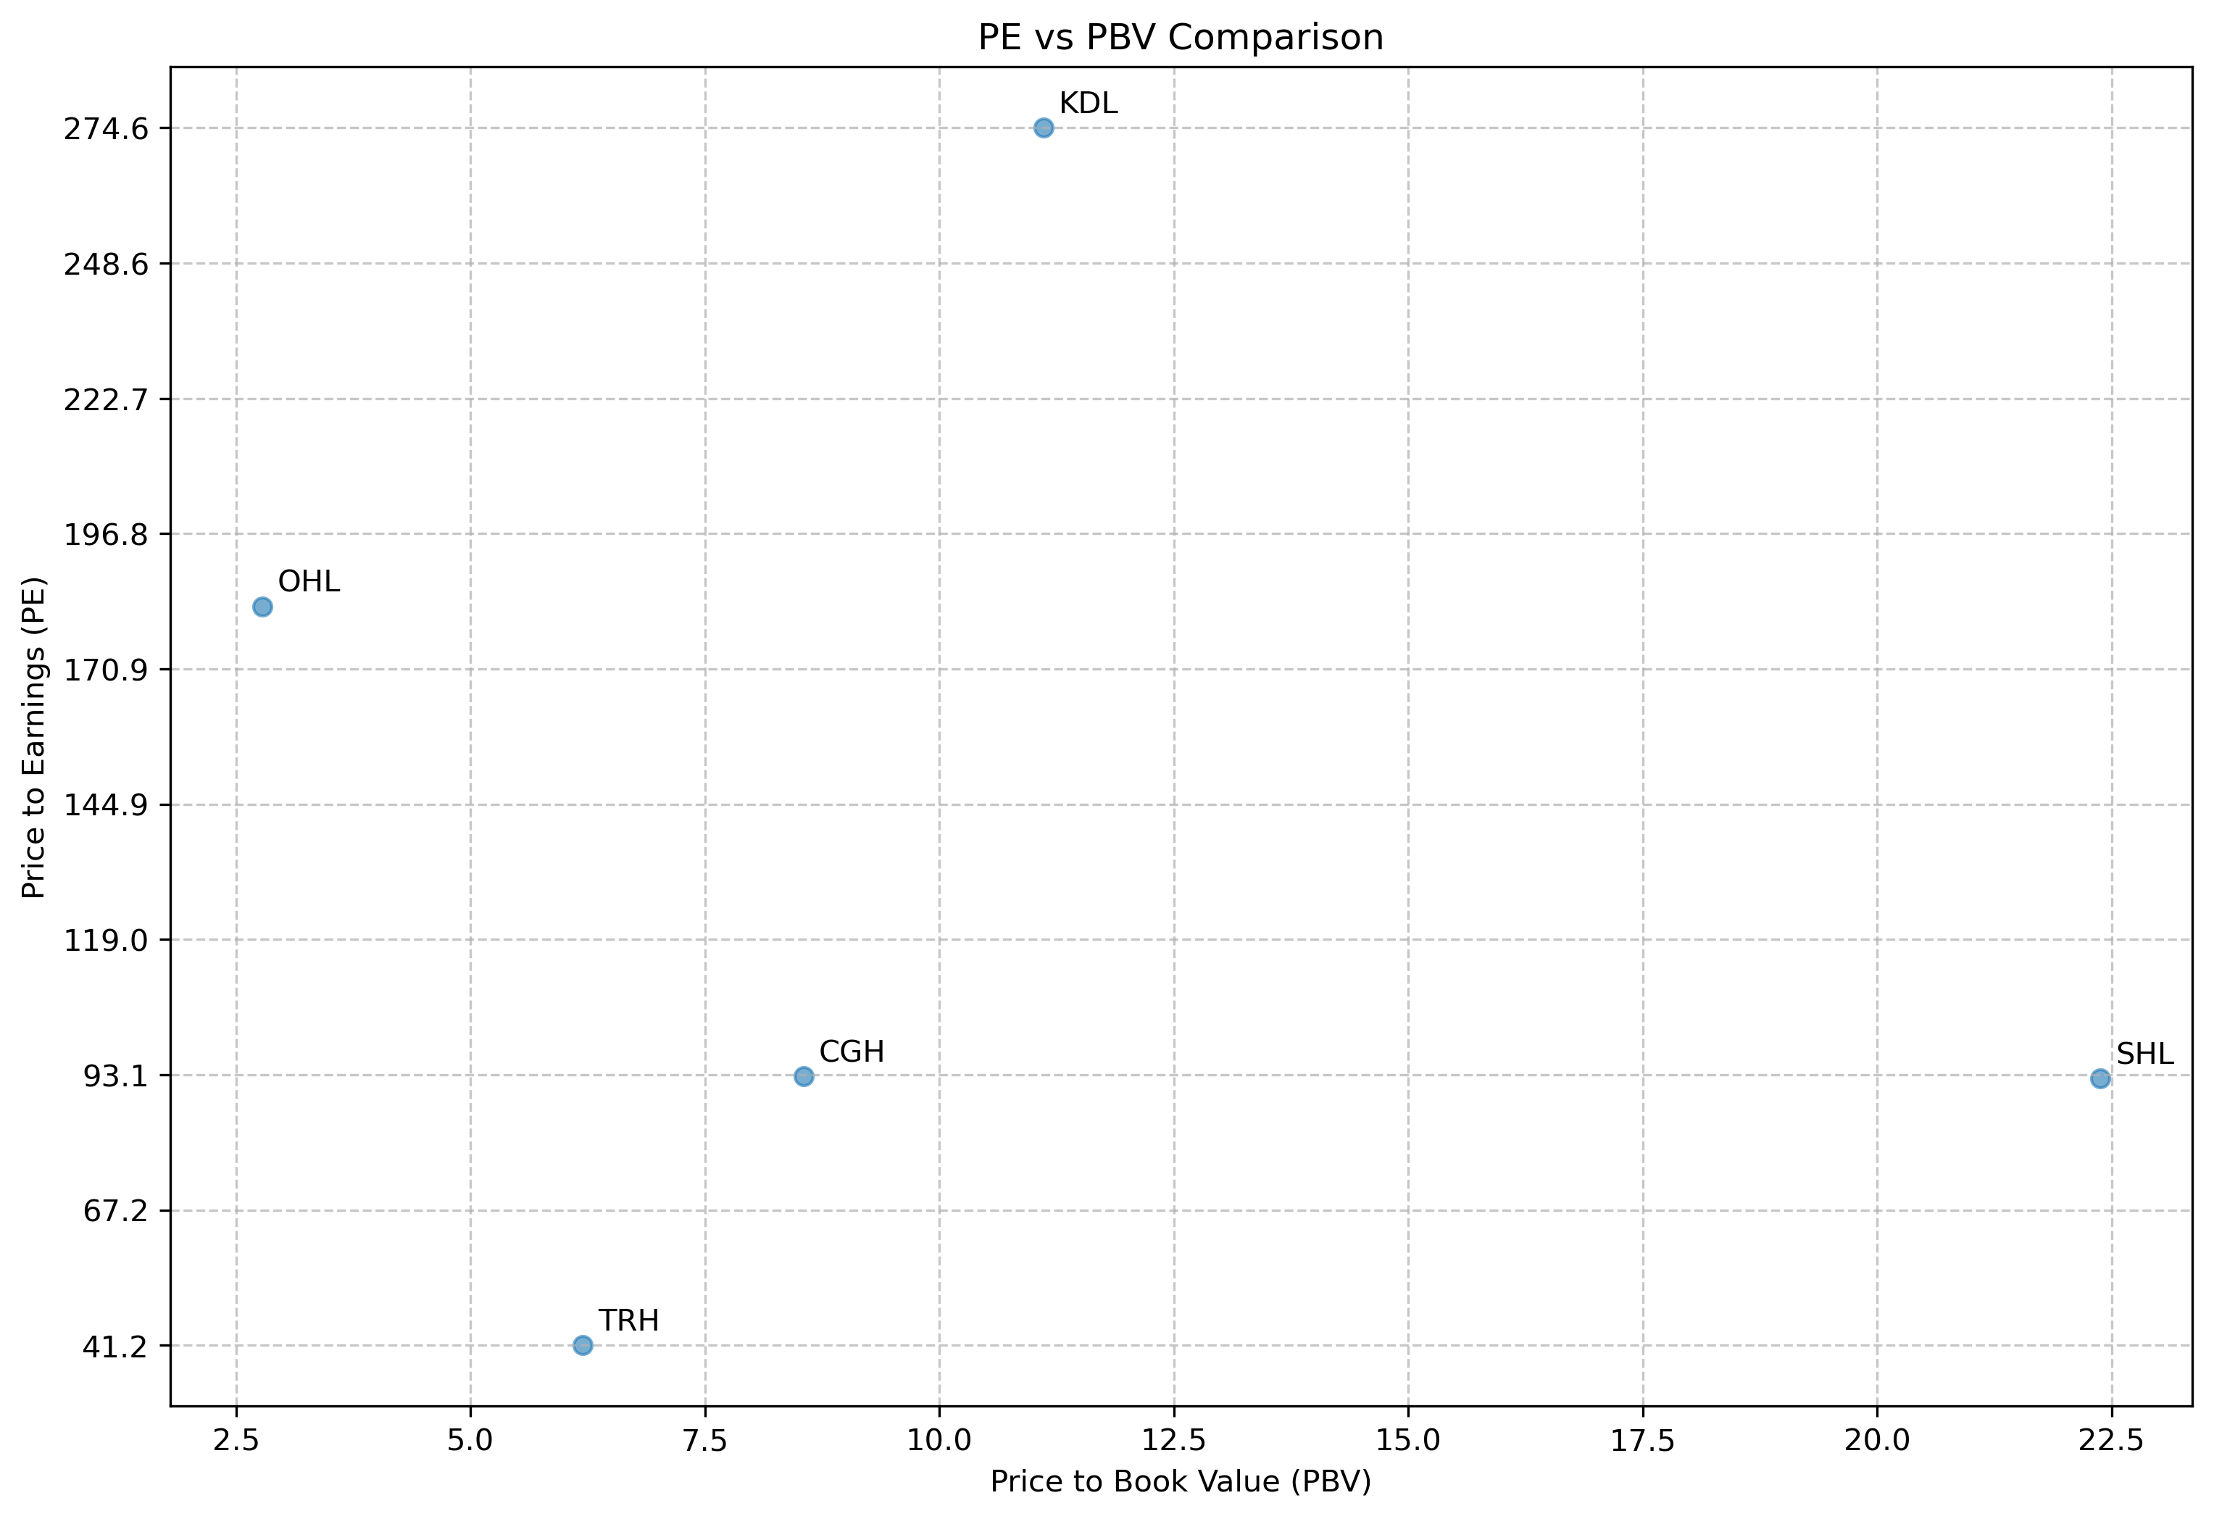

**Beta Analysis - Defensive Characteristics:** Most stocks exhibit low systematic risk (0.86-1.17 beta range), making the sector attractive for defensive allocation. SHL shows lowest volatility (0.86 beta) while maintaining growth characteristics.

## Solvency Ratios:

* **SHL & KDL -** Both maintain 0.08x debt-to-equity with exceptional interest coverage (290x and 4.33x respectively). Provide defensive characteristics during economic downturns.
* **TRH -** Completely debt-free structure offers maximum financial flexibility but may indicate underutilization of leverage for growth acceleration.
* **CGH & OHL -** 1.13x and 0.40x debt-to-equity respectively with adequate interest coverage (2.97x and 3.59x). Appropriate capital structure for hospitality operations.
* **CITY - Critical Leverage Concern:** 2.43x debt-to-equity with inadequate interest coverage (0.56x). High bankruptcy risk given negative operating cash flows and recent operational start.

## Profit Margins:

* **KDL - Margin Leader:** 60.17% gross margin due to cable car model's low variable costs. 27.33% net margin demonstrates pricing power in niche religious tourism.
* **SHL - Balanced Profitability:** 36.15% gross, 30.42% operating margins reflect operational efficiency and brand premium. Diversified revenue streams support margin stability.
* **TRH - Consistent Performance:** 41.72% gross, 36.68% operating, 28.88% net margins indicate well-managed operations despite ownership disputes.
* **CITY - Severe Margin Destruction:** Negative margins across all levels (-51.20% operating, -41.87% net) indicate fundamental operational problems requiring immediate restructuring.

## Dividend History

Historical Dividend Data:

|  |  |  |  |  |  |  |  |  |
| --- | --- | --- | --- | --- | --- | --- | --- | --- |
| **Company Name** | **Bonus (%) 2077-78** | **Cash (%) 2077-78** | **Bonus (%) 2078-79** | **Cash (%) 2078-79** | **Bonus (%) 2079-80** | **Cash (%) 2079-80** | **Bonus (%) 2080-81** | **Cash (%) 2080-81** |
| **OHL** |  |  |  |  |  | 5.26 | 5.00 | 0.26 |
| **SHL** |  |  | 5.00 | 21.32 | 5.00 | 26.58 | 10.00 | 26.84 |
| **TRH** |  |  | - | 8.42 | 4.00 | 11.00 | - | 11.00 |

* SHL has consistently provided attractive dividends with a mix of bonus and cash distributions, reflecting a shareholder-friendly policy.
* TRH and OHL also have a history of paying dividends, although more modest compared to SHL.

## Risk Management Metrics

|  |  |  |  |  |  |
| --- | --- | --- | --- | --- | --- |
| **SCRIPS** | **Beta Weekly** | **VaR 1 Week @5%** | **VaR 1 Month @5%** | **S.D. of returns [w,1Y] %** | **Mean returns [w,1Y] %** |
| **SHL** | 0.86 | -1.85% | -13.11% | 4.02% | 0.60% |
| **TRH** | 0.95 | -2.26% | -12.73% | 5.27% | 0.42% |
| **OHL** | 0.98 | -2.11% | -12.12% | 4.88% | 0.41% |
| **CGH** | 1.10 | -2.53% | -73.24% | 4.67% | 0.00% |
| **KDL** | 1.04 | -2.67% | -58.82% | 5.01% | 0.22% |
| **CITY** | 1.17 | -2.73% | -56.32% | 5.60% | 0.46% |

## Risk Management Analysis of Nepal's Hospitality Sector

### Overview of Risk Metrics

The risk management metrics provide critical insights into the volatility, potential losses, and risk characteristics of the six major hotel companies in Nepal's hospitality sector. These metrics help investors understand the risk-return profiles and potential downside scenarios for each investment option.

### Beta & Systematic Risk Profile

SHL demonstrates the lowest systematic risk (0.86 beta) while delivering superior returns, making it ideal for risk-adjusted portfolio allocation. TRH and OHL maintain near-market volatility (0.95-0.98 beta) with moderate risk profiles suitable for core holdings. However, CGH, KDL, and CITY show elevated systematic risk (1.04-1.17 beta), with CITY displaying the highest volatility (1.17 beta) compounding its operational distress concerns.

# Conclusion

The analysis of listed hotel companies in Nepal reveals a wide spectrum of performance, risk, and return profiles.  Established players like SHL, TRH, and OHL have accumulated reserves over decades. SHL (Soaltee Hotel) emerges as a market leader, characterized by strong profitability metrics, consistent returns, and low-risk indicators such as a low beta, low VaR, and stable standard deviation. TRH (Taragaon Regency) follows closely, offering a favorable balance of risk and return with competitive profitability margins and moderate market volatility.

Avoid stock like CITY, KDL due to bad performance.

Hence recommended to prioritize accumulation of SHL and TRH during market weakness

# Disclaimer:

* *This report is based on publicly available published data and is intended for informational purposes only. Any decision made based on this report are solely at the viewer discretion.*